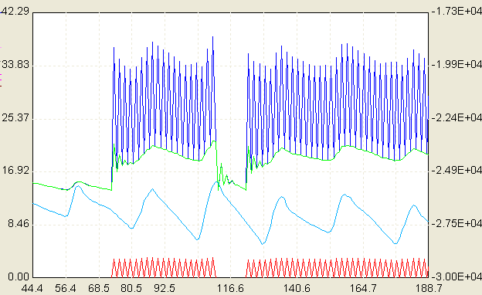
Dark Blue: Heat Pump outlet air temperature

Green: Room temperature

Blue: Outside ambient temperature

Red: Heat pump COP

The heat pump starts working when the room temperature is 14°C, which is good. However, then the room temperature increase significantly, to 22°C. So normally, at this temperature, the heat pump should not work and I don’t understand why here it is still working.

The controller setting is shown below:

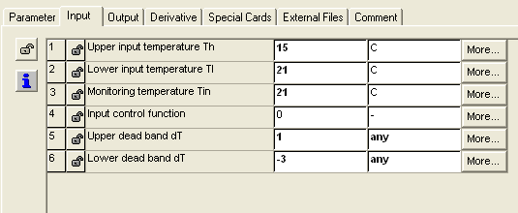

Note: The lower input temperature is the room temperature.

