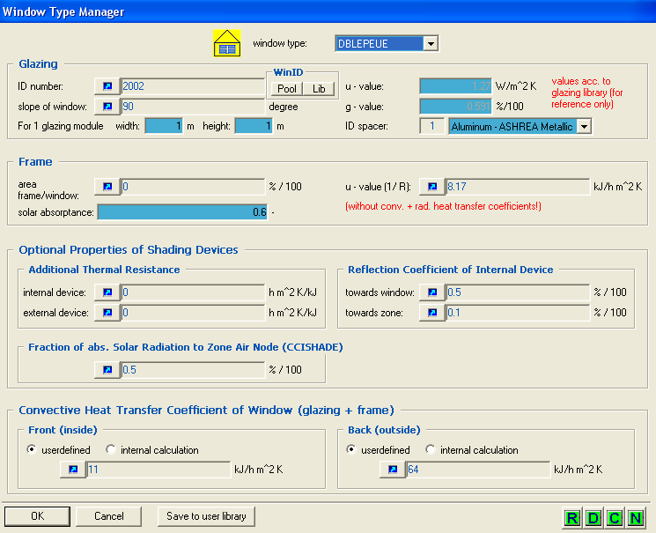

WINDOW 4.1 DOE-2 Data File : Multi Band Calculation

Unit System : SI
Name : TRNSYS 15 WINDOW LIB
Desc : Insulating,Ar, 1.3 71/59
Window ID : 2002
Tilt : 90.0
Glazings : 2
Frame : 11 2.270
Spacer : 1 Class1 2.330 -0.010 0.138
Total Height: 1219.2 mm
Total Width : 914.4 mm
Glass Height: 1079.5 mm
Glass Width : 774.7 mm
Mullion : None
Gap Thick Cond dCond Vis dVis Dens dDens Pr dPr
1 Argon 16.0 0.01620 5.000 2.110 6.300 1.780 -0.0060 0.680 0.00066
2 0 0 0 0 0 0 0 0 0
3 0 0 0 0 0 0 0 0 0
4 0 0 0 0 0 0 0 0 0
5 0 0 0 0 0 0 0 0 0
Angle 0 10 20 30 40 50 60 70 80 90 Hemis
Tsol 0.426 0.428 0.422 0.413 0.402 0.380 0.333 0.244 0.113 0.000 0.354
Abs1 0.118 0.118 0.120 0.123 0.129 0.135 0.142 0.149 0.149 0.000 0.132
Abs2 0.190 0.192 0.198 0.201 0.200 0.199 0.199 0.185 0.117 0.000 0.191
Abs3 0 0 0 0 0 0 0 0 0 0 0
Abs4 0 0 0 0 0 0 0 0 0 0 0
Abs5 0 0 0 0 0 0 0 0 0 0 0
Abs6 0 0 0 0 0 0 0 0 0 0 0
Rfsol 0.266 0.262 0.260 0.262 0.269 0.286 0.326 0.422 0.621 1.000 0.314
Rbsol 0.215 0.209 0.207 0.210 0.219 0.237 0.272 0.356 0.560 0.999 0.260
Tvis 0.706 0.710 0.701 0.688 0.670 0.635 0.556 0.403 0.188 0.000 0.590
Rfvis 0.121 0.115 0.114 0.118 0.132 0.163 0.228 0.376 0.649 1.000 0.203
Rbvis 0.103 0.096 0.093 0.096 0.108 0.132 0.179 0.286 0.520 0.999 0.162
SHGC 0.591 0.595 0.594 0.589 0.577 0.554 0.508 0.407 0.219 0.000 0.521
SC: 0.55

Layer ID# 9052 9064 0 0 0 0
Tir 0.000 0.000 0 0 0 0
Emis F 0.840 0.100 0 0 0 0
Emis B 0.840 0.840 0 0 0 0
Thickness(mm) 4.0 4.0 0 0 0 0
Cond(W/m2-C )225.0 225.0 0 0 0 0
Spectral File None None None None None None

Overall and Center of Glass Ig U-values (W/m2-C)
Outdoor Temperature -17.8 C 15.6 C 26.7 C 37.8 C
Solar WdSpd hcout hrout hin
(W/m2) (m/s) (W/m2-C)
0 0.00 12.25 3.24 7.60 1.46 1.46 1.20 1.20 1.23 1.23 1.35 1.35
0 6.71 25.47 3.21 7.63 1.53 1.53 1.23 1.23 1.27 1.27 1.40 1.40
783 0.00 12.25 3.39 8.05 1.61 1.61 1.42 1.42 1.37 1.37 1.39 1.39
783 6.71 25.47 3.29 7.89 1.71 1.71 1.51 1.51 1.43 1.43 1.43 1.43

